Start by exploring the happy_penguin_dance block.

When the user presses their space key Penguin should wear the costume penguin1
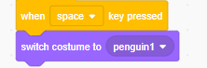
and be positioned at the point with coordinates (0, –100)
The user should be asked a price calculation question in the format shown in Figure 1.
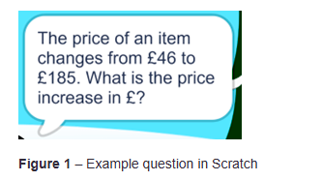
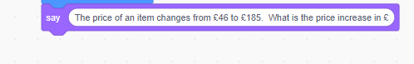

Both numbers should be whole numbers chosen at random.

